Rules:
- All fonts name must be Times New Roman.
- Font size of the abstract and Index Term (Keyword) must be 9 with bold.
- All Main Heading must be in CAPITAL LETTER with before line space 12, and after line space 4, and Line Spacing must be single. For this right, select the matter which not contain image or table, and go to paragraph and maintain as per norms.
- All Sub Heading must be in Sentence Case with italic that contain before line space 6, and after line space 3, and Line Spacing must be single. For this right, select the matter which not contain image or table, and go to paragraph and maintain as per norms.
Example:
  - MAIN HEADIND
First Sub Heading
- All the theoretical part of the main heading or sub heading must be font size 10 with line spacing Multiple at 1.05 with before and after line spacing at 0. For this right, select the matter which not contain image or table, and go to paragraph and maintain as per norms.
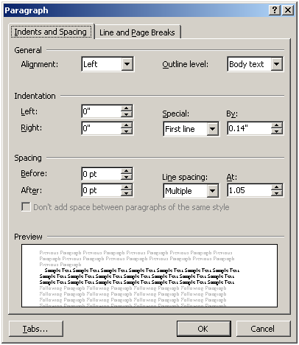

- Page size must be in double column as given in template
- Result Analysis (Chapter-5)
- Conclusion & Future Work (Chapter-6)
- References
- Reference must be font size 8, with single line Spacing and special hanging by 0.25.

For Example:
References
- G. O. Young, “Synthetic structure of industrial plastics (Book style with paper title and editor),” in Plastics, 2nd ed. vol. 3, J. Peters, Ed. New York: McGraw-Hill, 1964, pp. 15–64.
- W.-K. Chen, Linear Networks and Systems (Book style). Belmont, CA: Wadsworth, 1993, pp. 123–135.
- H. Poor, An Introduction to Signal Detection and Estimation. New York: Springer-Verlag, 1985, ch. 4.
- B. Smith, “An approach to graphs of linear forms (Unpublished work style),” unpublished.

